1. **What is software? What is software engineering?**  
     
   An application software is a type of software that automates tasks based on user input. It can handle single or multiple tasks simultaneously. Various applications assist us in daily activities by processing our instructions according to specific rules and regulations. Application software provides a graphical user interface, enabling users to perform various functions on a computer, such as browsing the internet, accessing email services, attending meetings, and playing games. High-level programming languages are used to develop application software.  
     
   Software engineering is a disciplined approach to the design, development, maintenance, and testing of software. It involves applying engineering principles to ensure that software is reliable, efficient, and meets user requirements. Key aspects of software engineering include Requirements Analysis, Design, Implementation, Testing, Maintenance, Project Management, and many more. Software engineering aims to produce high-quality software that is maintainable, scalable, and easy to use.  
     
    **2. Explain types of software**  
     
   Types of Application Software  
     
   **-Application Software**

Application software is the most common type of software, designed to perform specific functions for users or, in some cases, for other applications. It can be self-contained or part of a group of programs that work together to provide a complete solution. Examples of modern application software include:

- Office suites

- Graphics software

- Databases and database management programs

- Web browsers

- Word processors

- Software development tools

- Image editors

- Communication platforms

These applications assist users in a wide range of tasks, making computing more productive and efficient.  
  
**- System Software**

- These programs are designed to run a computer's application programs and manage hardware.

- System software coordinates the activities and functions of both hardware and software.

- It controls the operations of computer hardware and provides a platform for all other types of software to function.

- The operating system (OS) is the best example of system software, as it manages all other computer programs.

- Other examples of system software include firmware, computer language translators, and system utilities.  
  
**-Device Drivers**

**Device drivers** are essential software components that bridge the gap between a computer's operating system and its hardware devices. They act as translators, enabling the system to communicate effectively with peripherals like keyboards, printers, and graphics cards. Without appropriate drivers, these devices would be unable to function correctly.

As a critical part of system software, device drivers ensure smooth operation and optimal performance of connected hardware.  
  
**-Middleware**  
  
Middleware refers to software that acts as an intermediary between application and system software or between different types of application software. For instance, middleware facilitates communication between Microsoft Windows and applications like Excel and Word. It also allows an application on one operating system to interact with an application on a different operating system, and it helps newer applications work with older, legacy systems.

**-Programming Software**  
  
  
Computer programmers utilize programming software to write code and develop software applications. This type of software, which includes assemblers, compilers, debuggers, and interpreters, provides tools necessary for creating, testing, and debugging other software programs.  
  
**3. What is SDLC? Explain each phase of SDLC**  
  
  
The Software Development Life Cycle (SDLC) is a process used for planning, creating, testing, and deploying an information system. It typically involves several distinct phases, each with its specific tasks and deliverables. Here is a brief explanation of each phase:

1. Planning:

- Objective: Define the project scope, objectives, resources, and schedule.

- Activities: Feasibility study, project planning, resource allocation, and risk assessment.

2. Requirements:

- Objective: Gather and analyze business and technical requirements.

- Activities: Stakeholder interviews, document requirements, create requirements specification.

3. Design:

- Objective: Create the architecture and design of the system.

- Activities: Design system architecture, create data models, define system components.

4. Implementation (Coding):

- Objective: Develop the actual software based on the design specifications.

- Activities: Write code, integrate components, perform initial testing.

5. Testing:

- Objective: Ensure the software is free of defects and meets the requirements.

- Activities: Conduct various types of testing (unit, integration, system, user acceptance), report and fix bugs.

6. Deployment:

- Objective: Release the software to the production environment.

- Activities: Deploy software, conduct final testing, user training, and system handover.

7. Maintenance:

- Objective: Maintain and improve the system post-deployment.

- Activities: Fix bugs, make enhancements, provide support, and perform updates.

Each phase of the SDLC is crucial to ensuring the successful delivery and maintenance of a software product.  
  
  
4. **What is DFD? Create a DFD diagram on Flipkart**  
  
A Data Flow Diagram (DFD) is a graphical representation of the flow of data through an information system. It illustrates how data is processed by a system in terms of inputs and outputs. Here are the main components of a DFD:

1. Processes: Represented by circles or ovals, processes show how data is transformed from input to output.

2. Data Stores: Represented by open-ended rectangles or parallel lines, data stores depict where data is stored within the system.

3. Data Flows: Represented by arrows, data flows show the direction of data movement between processes, data stores, and external entities.

4. External Entities: Represented by squares or rectangles, external entities are outside systems or actors that interact with the system (e.g., users, other systems).

DFDs are useful for visualizing data processing, identifying redundancies, and improving system efficiency. They help stakeholders understand how data moves within the system and are often used during the requirements gathering and design phases of the SDLC.  
  
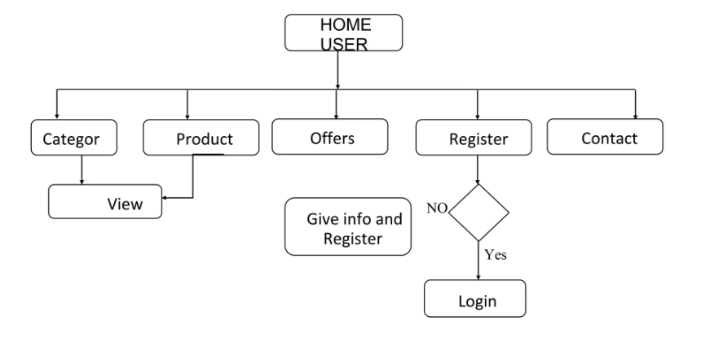  
  
  
  
  
  
**5.** **What is Flow chart? Create a flowchart to make the addition of two numbers**A flowchart is a visual representation of a process or a sequence of steps. It uses various symbols, such as arrows, rectangles, diamonds, and ovals, to depict different types of actions or decisions, illustrating how they connect and flow from one to the next.  
  
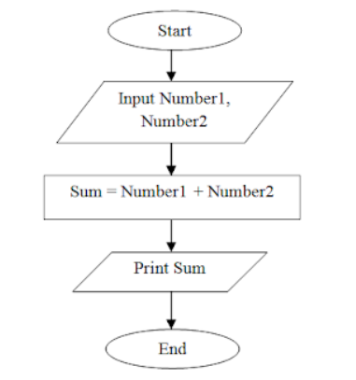  
  
  
**6. What is Use case Diagram? Create a use-case on bill payment on paytm.**  
  
A Use Case Diagram is a type of behavioral diagram in the Unified Modeling Language (UML) that represents the interactions between a system and its external entities, such as users (actors). It provides a visual overview of the functional requirements of a system, showing how different users will interact with the system and what functionalities the system should offer to fulfill those interactions.  
  
  
